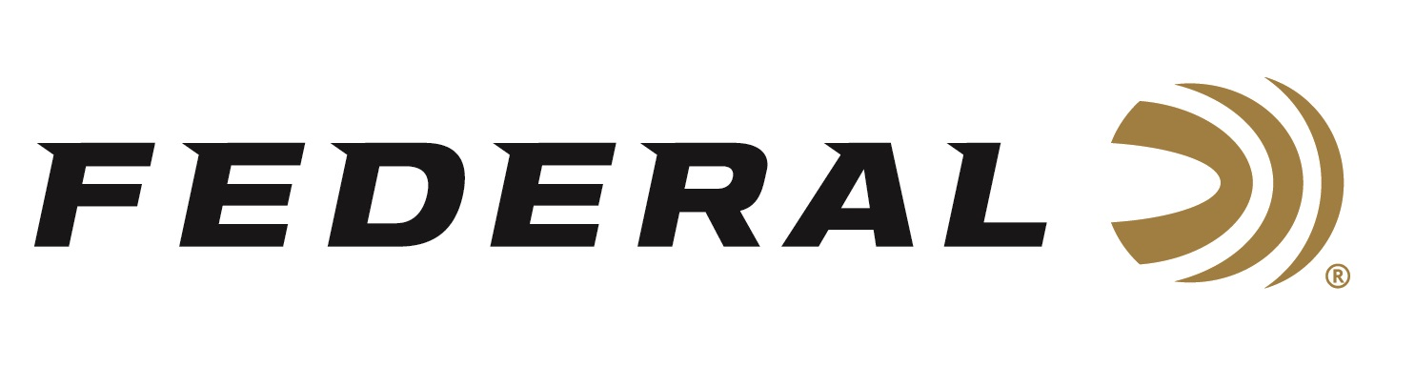

FOR IMMEDIATE RELEASE

Federal Ammunition Introduces New Terminal Ascent, The Best Choice for All-Range Hunting Loads

ANOKA, Minnesota – April 22, 2020 – Go beyond what you ever thought possible with new Federal Premium Terminal Ascent. Blending the features of top match-style bullet designs with the industry’s best bonding technology and components, Terminal Ascent delivers any-range accuracy and reliable expansion even at low velocities. This outstanding bullet design provides high weight retention, deep penetration and lethal terminal performance, both up close and at extreme distances. Now available in a full selection of long-range hunting cartridges including 280 Ackley Improved, 28 Nosler, 6.5 PRC and more. Shipments of this product have begun to arrive at dealers.

Bonded construction penetrates deep on close targets, while the patented Slipstream polymer tip initiates expansion at velocities 200 fps lower than comparable designs. The bullet’s long, sleek profile offers an extremely high ballistic coefficient, and its AccuChannel groove technology improves accuracy and minimizes drag.

“We took all the lessons learned during the past few decades building our own proprietary bullets and poured all that knowledge and experience into creating our best hunting bullet to date,” said Federal Centerfire Product Director Mike Holm. “We certainly credit using some of our existing, time-tested bullet designs to inspire the development of this new hunting bullet. Proven designs such as Trophy Bonded Bear Claw, Trophy Bonded Tip and Edge TLR all helped pave the way to create our all-new Terminal Ascent.”

Terminal Ascent also features high-end nickel plating that is corrosion-resistant to give the cartridge an outstanding appearance with smooth operation. This finishing makes Terminal Ascent look like a fine piece of jewelry. And the use of clean-burning propellant and an ultra-reliable, sealed primer—as well as its neon electric-blue polymer tip—produces a sleek-looking, high-performance cartridge that’s sure to impress.

“Terminal Ascent is simply the best all-range, all-velocity hunting ammunition available,” concluded Holm.

Features & Benefits
- Match-grade long-range accuracy in a bonded hunting bullet
- Extremely high ballistic coefficient
- Exclusive Slipstream polymer tip helps flatten trajectories and initiate low-velocity expansion
- Less wind drift and drop
- AccuChannel groove technology minimizes drag
- Copper shank and bonded lead core retain weight for deep penetration at any range

Part No. / Description / MSRP
P65CRDTA1 / 6.5 Creedmoor 130 grain, 2825 fps, .532 G1 BC / $58.99
P65PRCTA1 / 6.5 PRC 130 grain, 3000 fps,.532 BC / $59.99
P270TA1 / 270 Win. 136 grain, 3000 fps, .493 G1 BC / 50.99
P270WSMTA1 / 270 Win. Short Mag 136 grain, 3240 fps, .493 G1 BC / $51.99
P280AITA1 / 280 Ackley Imp. 155 grain, 2930 fps, .586 G1 BC / $58.99
P28NTA1 / 28 Nosler 155 grain, 3200 fps, .586 BC / $65.99
P7TA1 / 7mm Rem. Mag 155 grain, 3000 fps, .586 G1 BC / $56.99
P308TA1 / 308 Win. 175 grain, 2600 fps, .520 G1 BC / $47.99
P3006TA1 / 30-06 Sprg. 175 grain, 2730 fps, .520 G1 BC / $47.99
P300WTA1 / 300 Win Mag 200 grain, 2810 fps, .608 G1 BC / $59.99
P300WSMTA1 / 300 WSM 200 grain, 2810 fps, .608 G1 BC / $59.99

Federal ammunition can be found at dealers nationwide or purchased online direct from Federal. For more information on all products from Federal or to shop online, visit www.federalpremium.com.

Press Release Contact: JJ Reich
Senior Manager – Press Relations
E-mail: VistaPressroom@VistaOutdoor.com

About Federal Ammunition
Federal, headquartered in Anoka, MN, is a brand of Vista Outdoor Inc., an outdoor sports and recreation company. From humble beginnings nestled among the lakes and woods of Minnesota, Federal Ammunition has evolved into one of the world's largest producers of sporting ammunition. Beginning in 1922, founding president, Charles L. Horn, paved the way for our success. Today, Federal carries on Horn's vision for quality products and service with the next generation of outdoorsmen and women. We maintain our position as experts in the science of ammunition production. Every day we manufacture products to enhance our customers' shooting experience while partnering with the conservation organizations that protect and support our outdoor heritage. We offer thousands of options in our Federal Premium and Federal® lines-it's what makes us the most complete ammunition company in the business and provides our customers with a choice no matter their pursuit.

